# **Pizza Restaurant Menu Showcase Documentation**

## **Introduction**

### **Overview**

This project is a **Pizza Restaurant Menu Showcase**, designed to display the restaurant's products and their details to potential customers. The website pulls product data dynamically via a **Spring Boot API**, with data stored in a **MySQL database** running on **Docker Desktop**. The primary focus is to provide an engaging and visually appealing interface to showcase the menu items.

### **Goals and Objectives**

* **Product Display**: Highlight the restaurant’s menu items with images, descriptions, and prices.
* **Dynamic Content**: Ensure the menu is up-to-date by loading data directly from the backend API.
* **Responsive Design**: Provide a seamless user experience across devices.

## **Technical Documentation**

### **System Architecture**

* **Backend**: Spring Boot API, Maven
* **Frontend**: AngularJS, JavaScript, HTML, CSS
* **Database**: MySQL running on Docker Desktop
* **Hosting Platform**: Local

### **Flowchart**

Customer -> [Frontend Application] -> [Spring Boot API] -> [MySQL Database (Docker)]

#### **Flowchart Description:**

1. **Customer Interaction**: Users browse the website to explore menu items.
2. **Backend API**: The Spring Boot API fetches product data from the MySQL database.
3. **Frontend Display**: The menu items are displayed dynamically using API responses.

### **Page Descriptions**

1. **Homepage (index.html)**

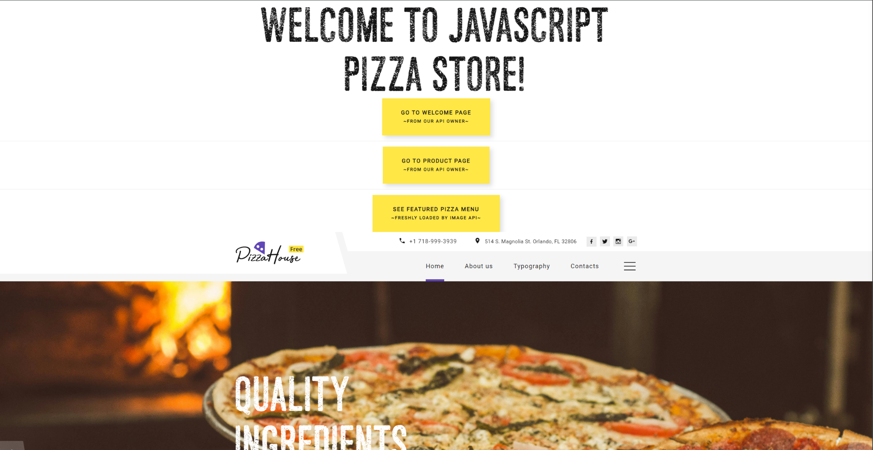

* + **Purpose**: Serves as the landing page for the website.
  + **Features**:
    - **Welcome banner**: shows message load from Spring API
    - 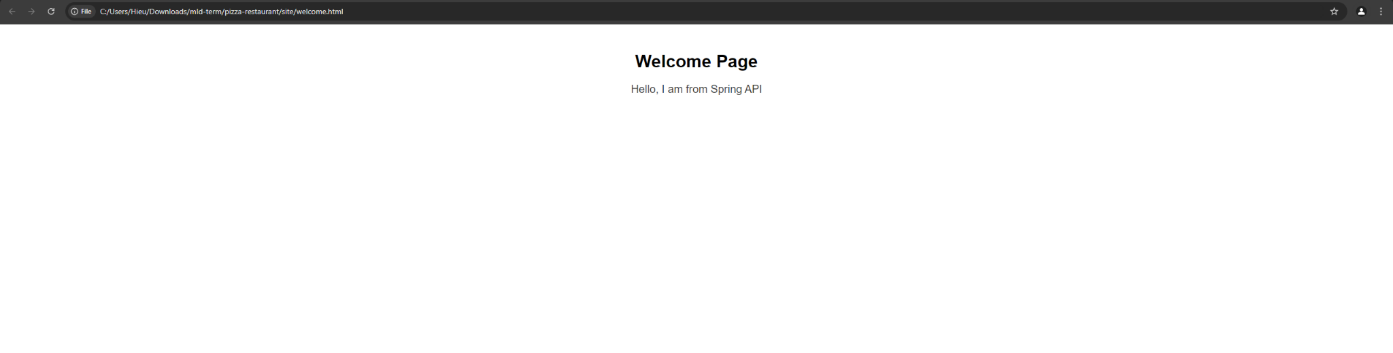
    - **Product banner**: shows products and prices hibernated from Docker Container within Spring Boot application. Retrieves data using the API endpoint /api/products/{id}.
    - 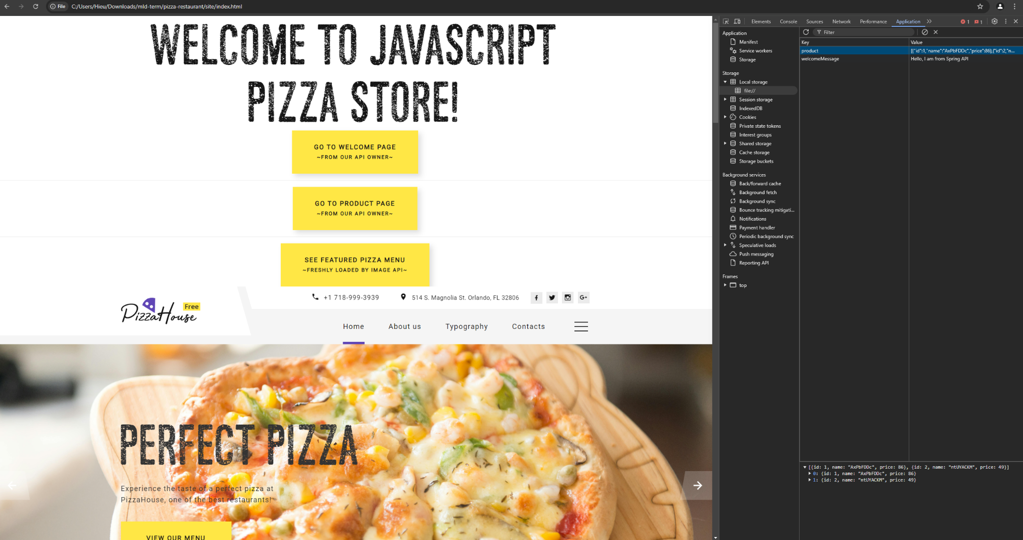
    - **Featured menu banner**: loads image from Spring Api
    - 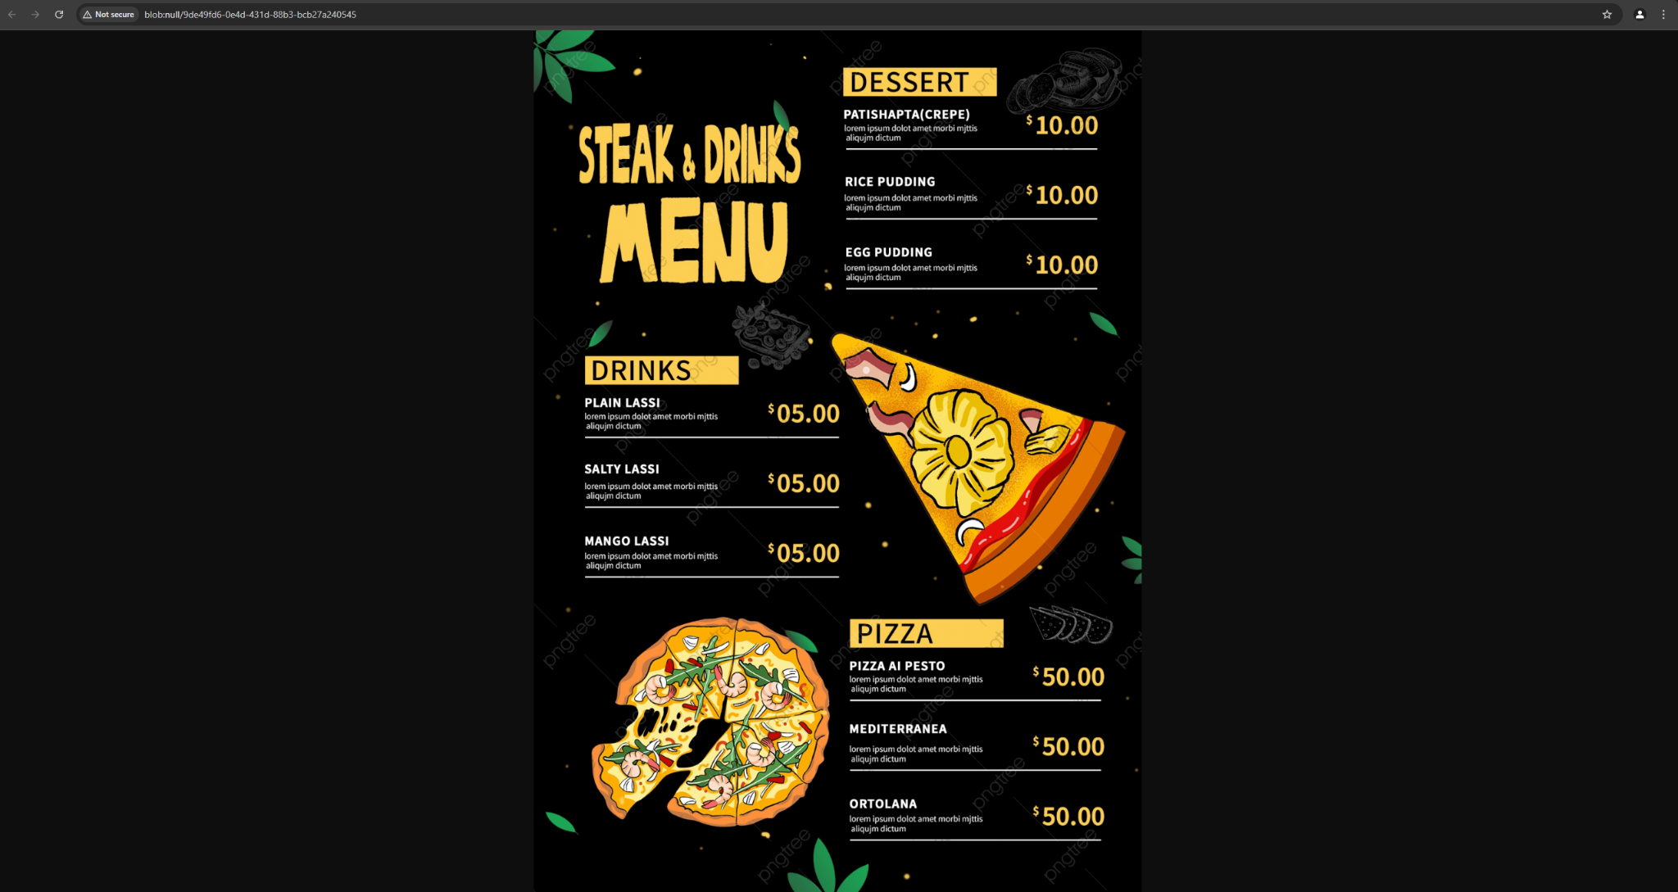
    - Quick navigation links to menu categories (e.g., Home, About Us, Typography, Contacts)

1. **Extended Homepage (index.html)**
   * **Purpose**: Showcases the full menu with categories and product details.
   * 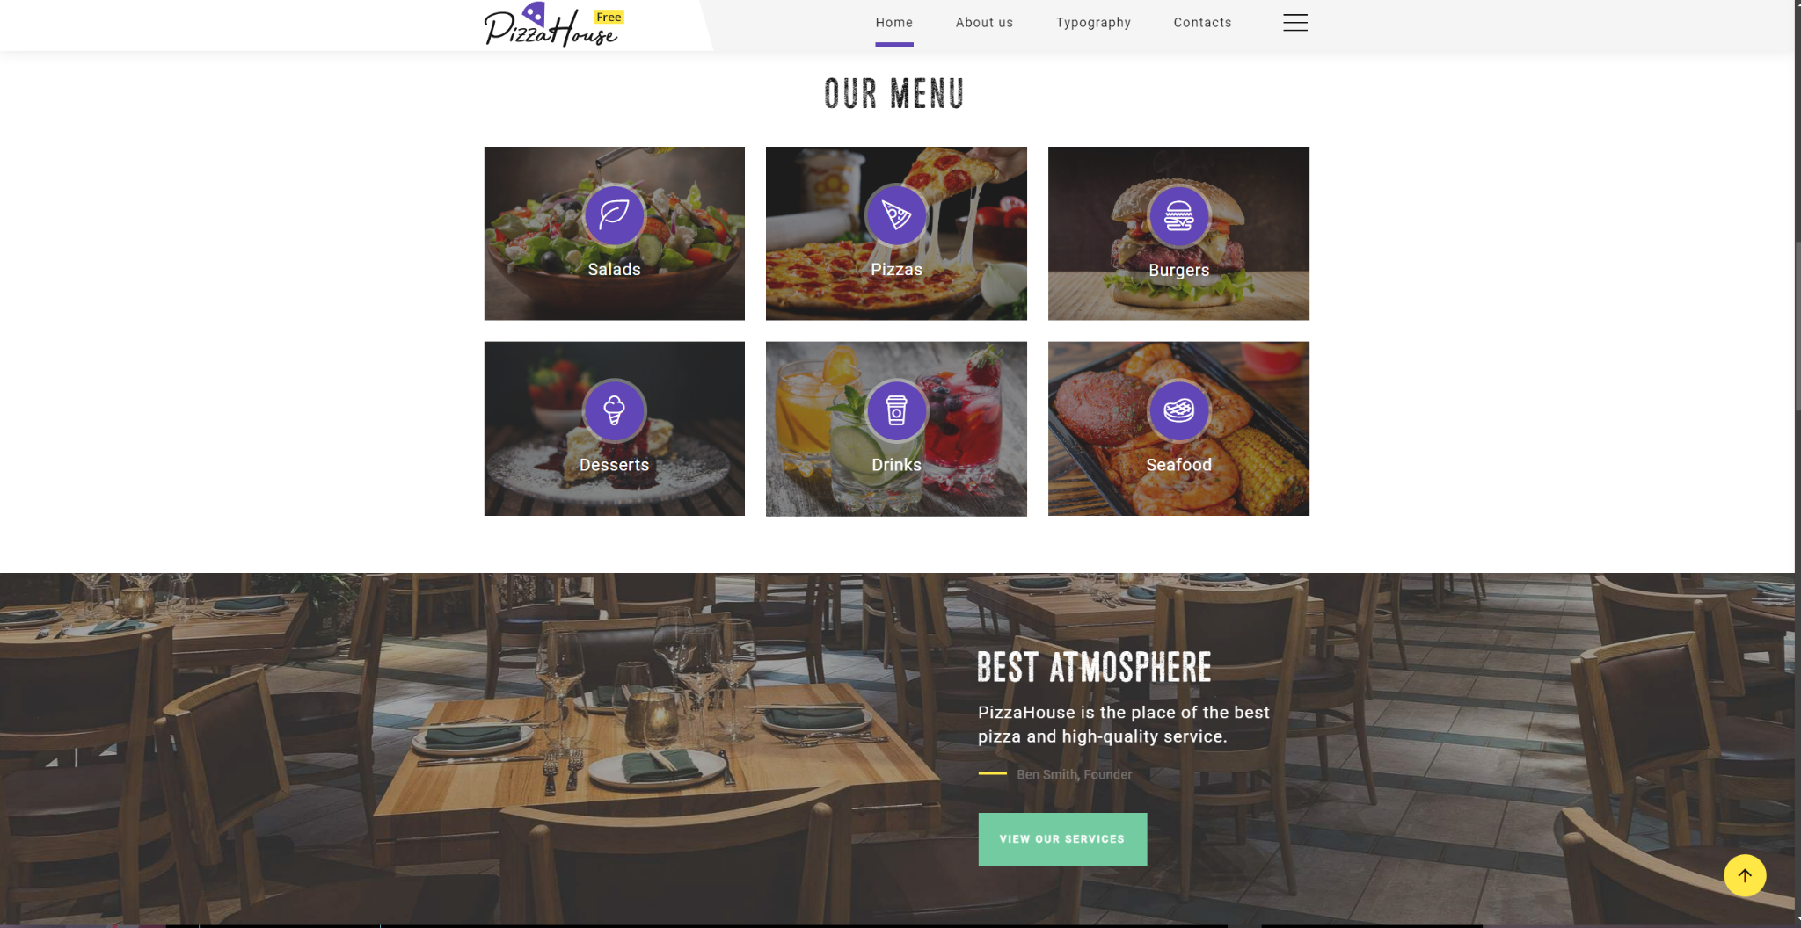
   * **Features**:
     + Displays product name, description, price, and image
     + Dynamic data loading from Spring Boot API
   * **Technical Details**: Utilizes REST endpoints such as /api/products to fetch product data.
2. **About Us Page**
   * **Purpose**: Describes the restaurant’s history and values.
   * 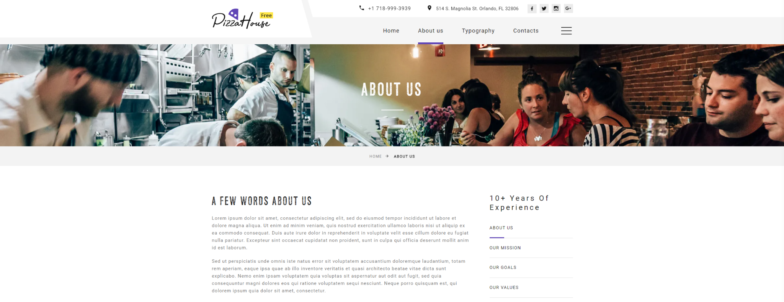
   * **Features**:
     + Text sections about the restaurant
3. **Contact Us Page**
   * **Purpose**: Allows users to find contact details and submit inquiries.
   * 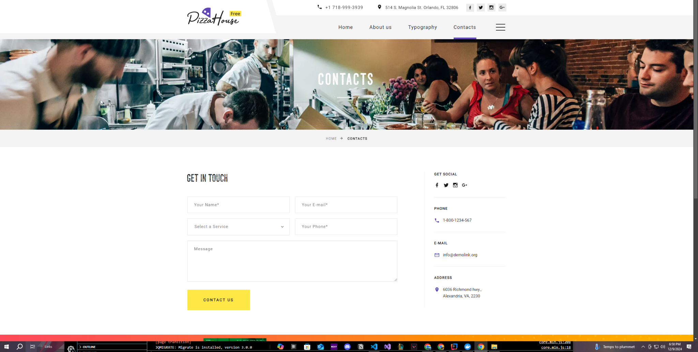
   * **Features**:
     + Contact form
     + Display of address and phone number

### **API Endpoints Description:**

**I: WELCOME MESSAGE API**

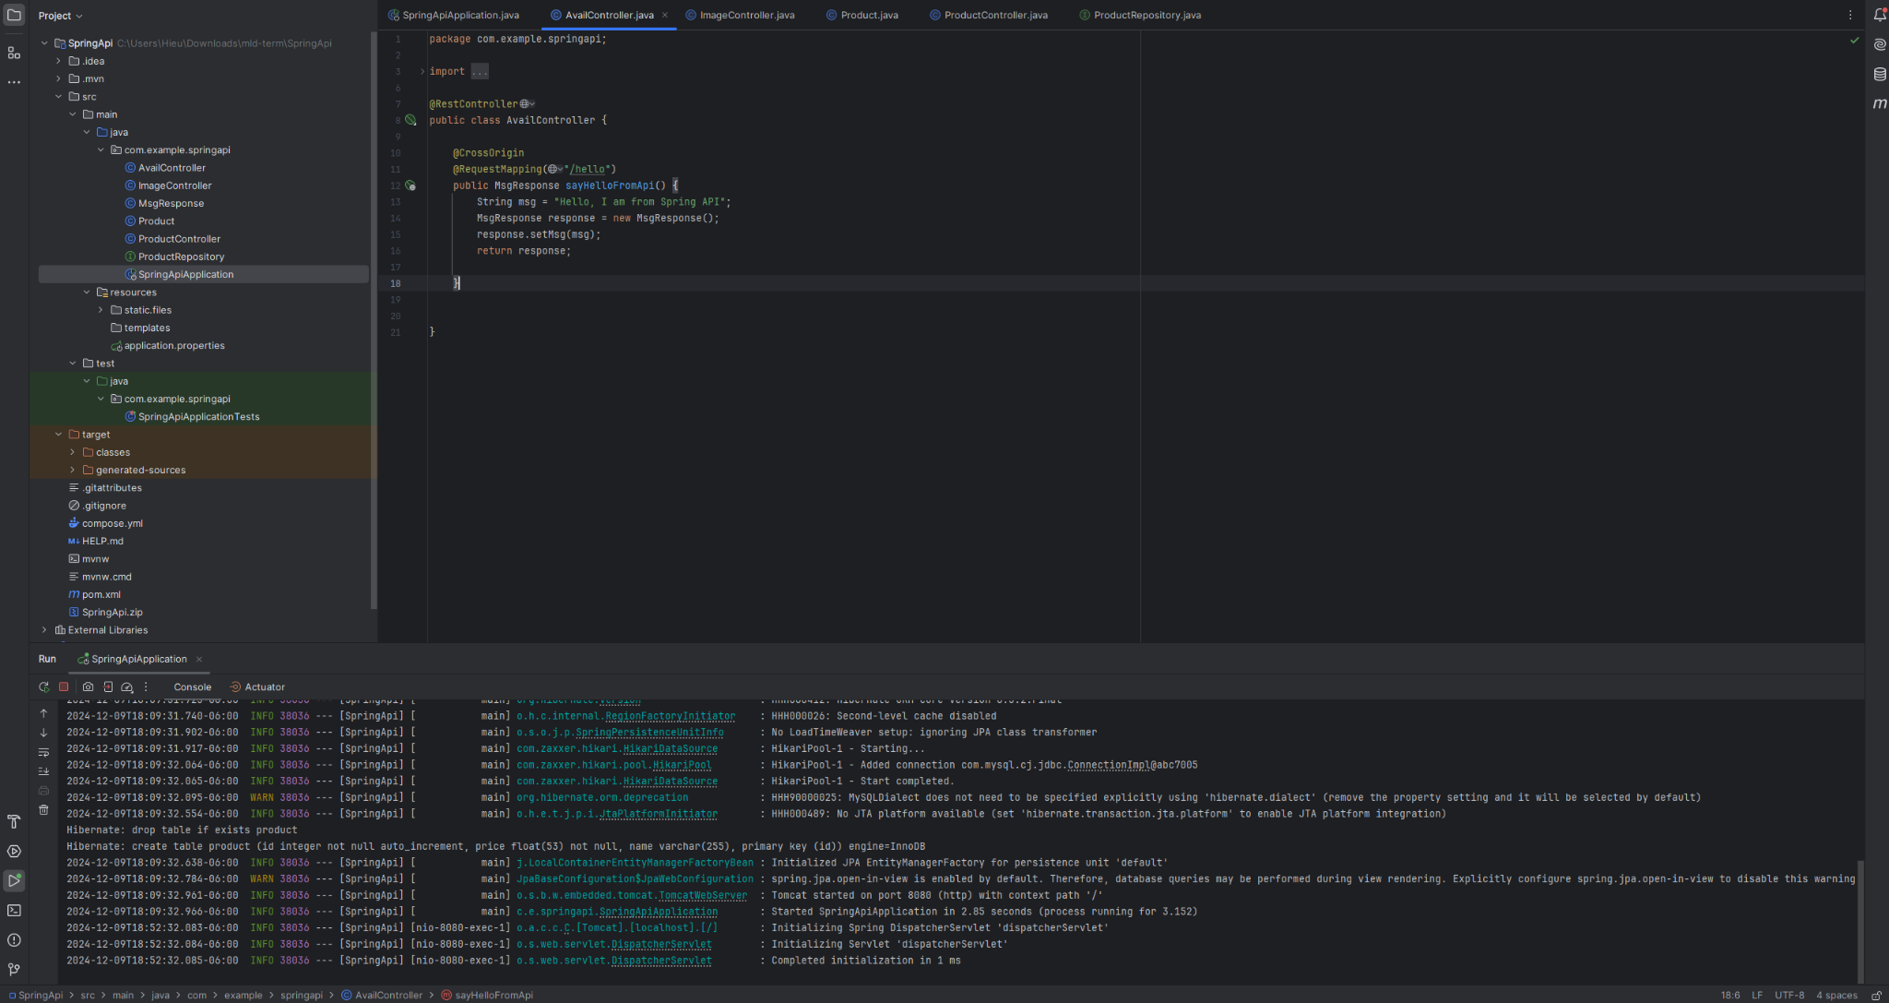

This AvailController in Spring Boot API is designed to deliver a welcome banner message to the connected frontend application. The API provides a single endpoint (/hello) that returns a predefined message in a structured JSON response. It uses a custom response object (MsgResponse) for encapsulating the message. **Code Analysis below:**

1. **Controller Class**:
   * **Class Name**: AvailController
   * **Annotation**:
     + @RestController: Indicates that the class is a REST controller, automatically mapping return values to JSON format.
   * **Purpose**: Exposes the /hello endpoint for delivering the welcome message.
2. **Endpoint Configuration**:
   * **Path**: /hello
   * **Annotation**:
     + @RequestMapping: Maps HTTP requests to the /hello URL.
     + @CrossOrigin: Allows cross-origin resource sharing (CORS), enabling the API to be accessed from different origins, such as the frontend application hosted on a different domain or port.
3. **Method**:
   * **Name**: sayHelloFromApi
   * **Return Type**: MsgResponse
   * **Functionality**:
     + Creates a MsgResponse object.
     + Sets the message string ("Hello, I am from Spring API") as its property.
     + Returns the populated MsgResponse object to the requester.
4. **Response Class** (MsgResponse):
   * **Purpose**: Encapsulates the message string in a structured JSON format.
   * **Structure**:  
     json  
     Copy code  
     {
   * "msg": "Hello, I am from Spring API"
   * }

#### **Technical Details below:**

1. **Backend Configuration**:
   * Spring Boot REST API application.
   * The @CrossOrigin annotation ensures seamless communication between the backend API and the AngularJS-based frontend, resolving CORS issues.
2. **API Functionality**:
   * The /hello endpoint listens for HTTP GET requests.
   * The response contains a JSON object with a msg key, providing the welcome message.
3. **Integration with Frontend**:
   * **Frontend Script**:
     + The AngularJS $http.get() method can fetch the message from http://localhost:8080/hello.
   * **Data Display**: The fetched msg value is dynamically displayed on the webpage using AngularJS bindings.
4. **Cross-Origin Compatibility**:
   * The @CrossOrigin annotation ensures compatibility with frontend origins hosted on different ports or domains (e.g., localhost:3000).
5. **Error Handling**:
   * If the endpoint is unreachable, the AngularJS controller can display an appropriate error message.

* Featuring Menu Image
* Product Information

**II: FEATURED MENU IMAGE API**

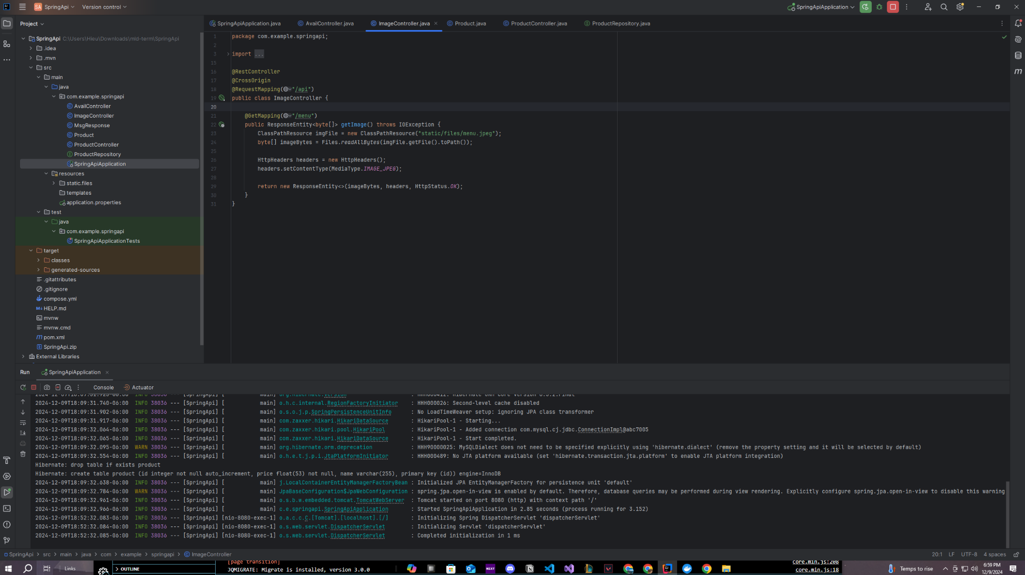

The ImageController in the Spring Boot API configuration facilitates serving a featured menu image to the frontend application. Below are the key technical details:

#### **Technical Details below:**

**Controller Setup**:

* The ImageController is annotated with @RestController to handle HTTP requests and return responses.
* The @RequestMapping("/api") specifies the base path for API endpoints, while @GetMapping("/menu") defines the specific endpoint to fetch the menu image.

**CORS Configuration**:

* The @CrossOrigin annotation allows cross-origin requests, enabling the frontend application to access the API from different domains.

**Image Handling**:

* The ClassPathResource class is used to locate the image file (menu.jpeg) stored in the static/files directory within the classpath.
* The Files.readAllBytes method reads the image file into a byte array for transmission in the HTTP response.

**HTTP Response**:

* The HttpHeaders object sets the Content-Type to MediaType.IMAGE_JPEG, indicating that the response contains a JPEG image.
* The image data is wrapped in a ResponseEntity<byte[]> with an HTTP 200 OK status code for successful responses.

**Frontend Integration**:

* The frontend fetches the image from the /api/menu endpoint, ensuring dynamic retrieval and display of the featured menu image on the website.

**III: PRODUCT INFORMATION API**

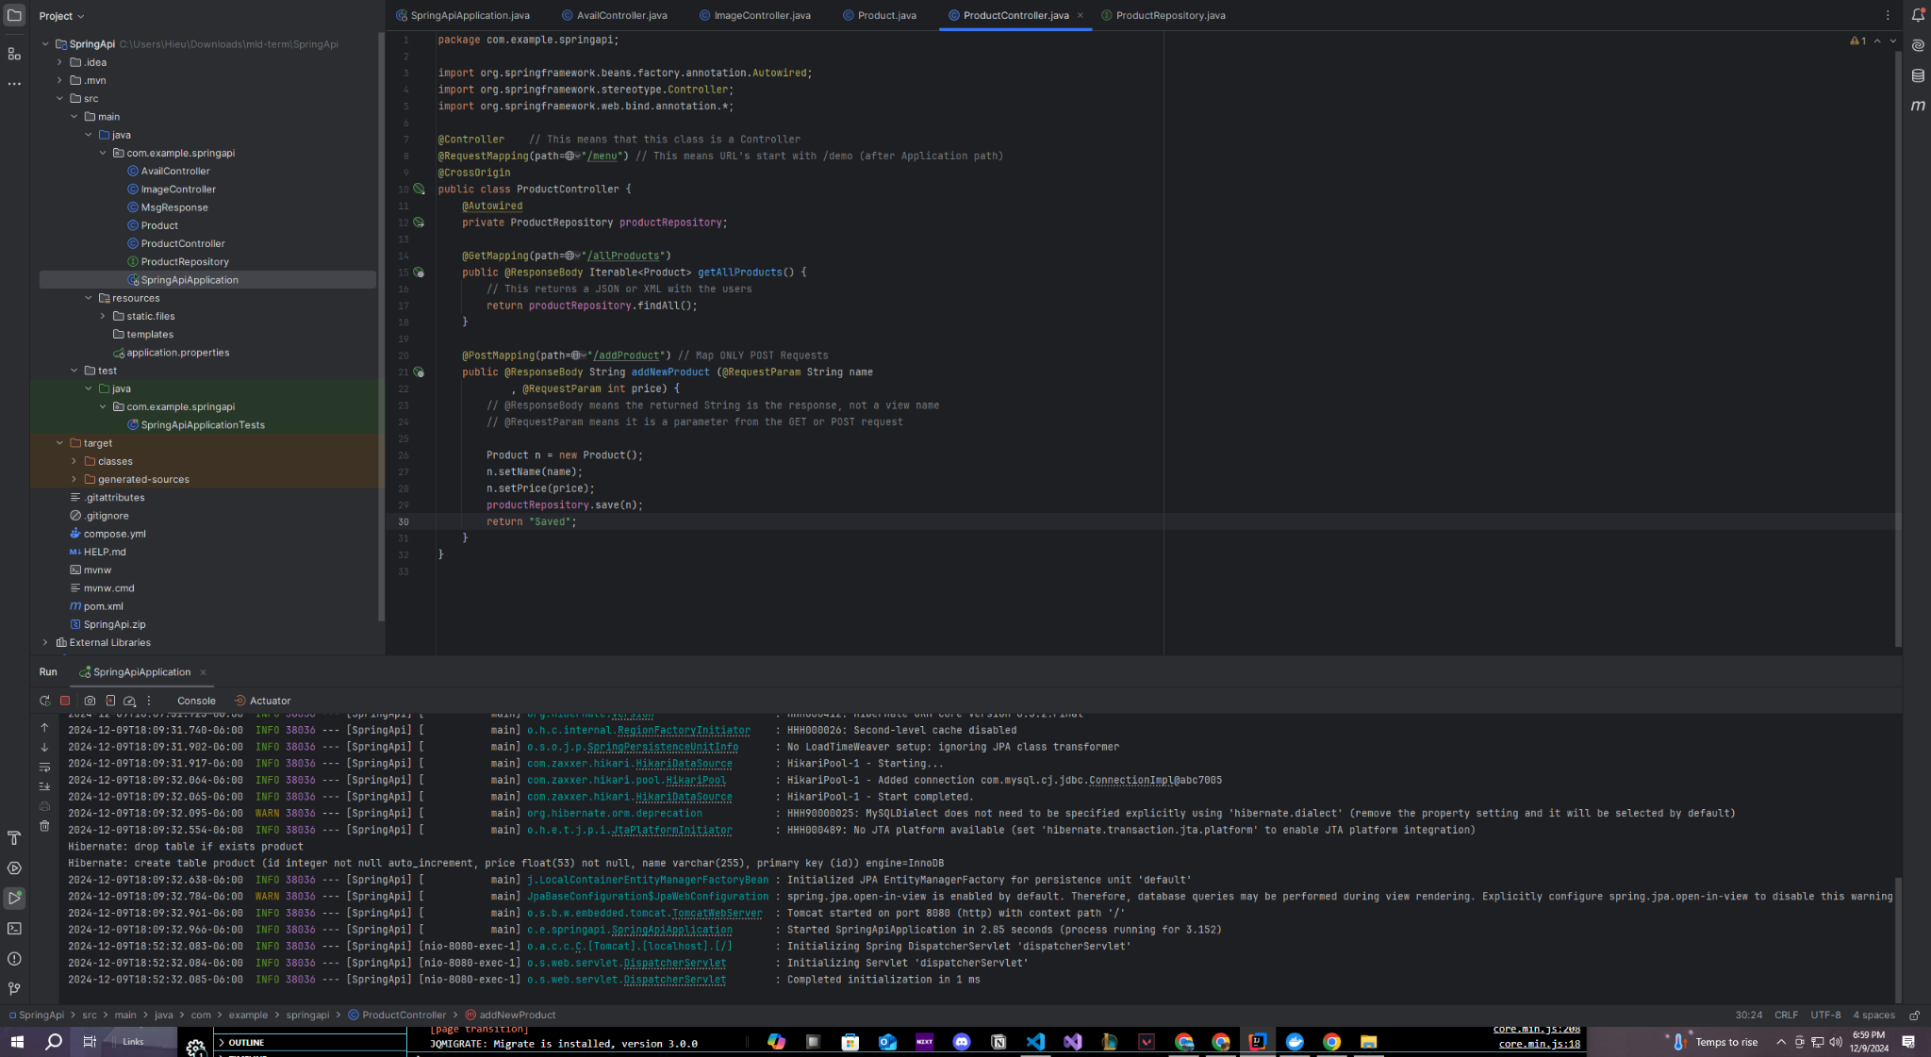

The ProductController class in the Spring Boot API handles HTTP requests related to product operations for the pizza restaurant. It enables two main functionalities:

1. Retrieving all products.
2. Adding a new product.

The API is connected to a repository (ProductRepository) which interacts with a **MySQL database** to fetch and persist data. The API supports cross-origin requests, allowing the AngularJS-based frontend to access it.

### **Components**

#### **Controller Class**

* **Annotation**: @Controller  
  Declares the class as a Spring MVC controller to handle web requests.
* **Request Mapping**: @RequestMapping(path="/menu")  
  Specifies the base URL path (/menu) for all endpoints in this controller.
* **Cross-Origin Support**: @CrossOrigin  
  Allows requests from different origins, essential for frontend-backend communication in a distributed architecture.

#### **Dependency Injection**

* @Autowired  
  Injects the ProductRepository bean, allowing the controller to use its methods for database operations.

### **Endpoints**

#### **1. Retrieve All Products**

* **Endpoint**: /menu/allProducts
* **Method**: GET
* **Return Type**: Iterable<Product>
  + Returns all product entries from the database as a JSON or XML response.
* **Implementation**:
  + Calls findAll() from the ProductRepository to fetch all products.
  + The @ResponseBody annotation ensures the data is sent as a response, not as a view.

#### **2. Add New Product**

* **Endpoint**: /menu/addProduct
* **Method**: POST
* **Parameters**:
  + name (String): Name of the product.
  + price (int): Price of the product.
* **Return Type**: String
  + Returns a confirmation message ("Saved") upon successful addition of the product.
* **Implementation**:
  + Creates a new Product object, sets its attributes, and saves it to the database using productRepository.save(n).

## **User Documentation**

### **Getting Started**

1. **Access the Website**:
   * Visit the URL provided by the restaurant.
2. **System Requirements**:
   * Any modern web browser (Chrome, Firefox, Edge, Safari).

### **Website Features**

1. **Browse the Menu**:
   * Navigate to the menu page to view all products.
   * Use filters to narrow down options by category.
2. **View Product Details**:
   * Click on any menu item to see its detailed description and additional information.
3. **Contact the Restaurant**:
   * Visit the “Contact Us” page to send an inquiry or find contact details.

### **Common Issues and Troubleshooting**

1. **Issue**: Menu items not displaying.  
   **Solution**:
   * Ensure the backend API is running.
   * Check the connection to the MySQL database within Docker Desktop.
2. **Issue**: Images not loading.  
   **Solution**:
   * Verify that the image files are stored in the correct directory or that their URLs are properly linked in the API responses.
3. **Issue**: Contact form submission not working.  
   **Solution**:
   * Confirm that the email service is properly configured in the backend.